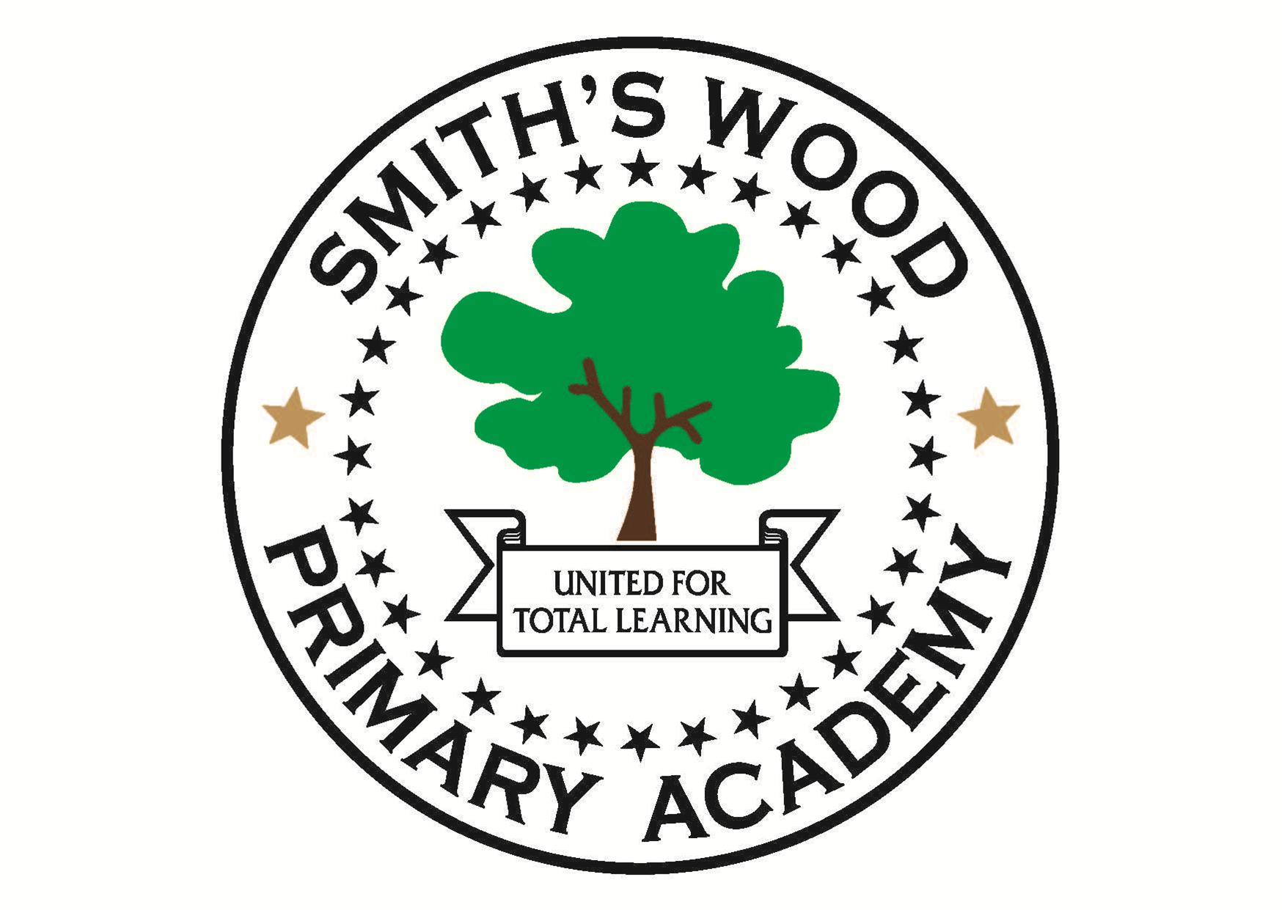

Part time School Counsellor required for Smith’s Wood Primary Academy

Required As Soon As Possible
Hours: 13 hours a week, Thursday and Friday. Term time only plus 2 inset days.
Salary: Band D (FTE £20,541 - £29,055) pro rata. Actual salary (£6,062 - £8,575).
The point of the scale will depend on experience

Smith’s Wood Primary Academy require a qualified Counsellor to start as soon as possible. The job purpose is to provide a professional and confidential counselling service to children, promoting their emotional health and well-being and building their resilience to help them cope with the difficulties they face. To carry out this role you must be fully qualified and registration with BACP is essential.

Visits are welcome, please contact the school office.

For application forms and further details, please visit the school website:
www.smithswoodpri.solihull.sch.uk

Alternatively you can contact
office@smithswoodpri.solihull.sch.uk

Or call the school office on 0121 779 8050

Closing date for the vacancy is 12 noon on Tuesday 25th September 2018. We anticipate interviews are to be held week commencing 1st October 2018.

Smith’s Wood Primary Academy is committed to safeguarding and promoting the welfare of children
and young people, and expects all staff to share this commitment. An enhanced DBS check is required for all successful candidates.

