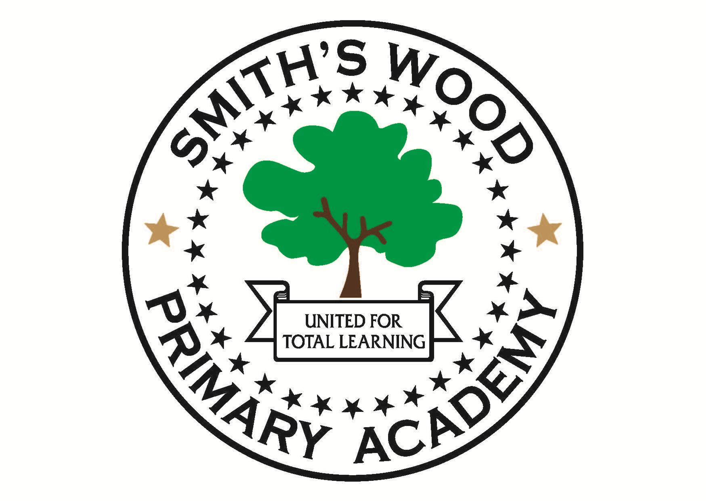

Lead Behaviour professional required for Smith’s Wood Primary Academy

Hours: 17.5 hours per week, Monday – Friday 12.15pm – 3.45pm. Term time only plus 2 inset days. Additional hours may be available if requested.
Salary: Band D point 21 -32 £20451 - £29055 (FTE) pro rata.
Actual salary £8067 - £11411.

The point of the scale will depend on experience. This is a permanent position.
Smith’s Wood Primary Academy are looking for a highly skilled Lead Behaviour professional to join us in our OFSTED ‘Outstanding’ school. We can offer you an innovative learning environment and the chance to make a real difference.

For application forms and further details, please visit the school website:
www.smithswoodpri.solihull.sch.uk

Alternatively you can contact
office@smithswoodpri.solihull.sch.uk

Or call the school office on 0121 779 8050

Visits are welcome, please contact the school office.
Closing date for the vacancy is 12 noon on Tuesday 25th September 2018. We anticipate interviews are to be held week commencing 1st October 2018.

Smith’s Wood Primary Academy is committed to safeguarding and promoting the welfare of children and young people, and expects all staff to share this commitment. An enhanced DBS check is required for all successful candidates.

